AN EXPLORATION OF AGRICULTURAL NEEDS PERTAINING TO SOFTWARE

-Sarthak Tandon, Akshita Aggarwal, Rahmeen Habib

**ABSTRACT___________________________________________________________________**

The following research paper serves to demonstrate the findings of a research trek conducted in Goyla Dairy Farms, Dwarka, New Delhi in a structured manner that highlights the intricacies of current rural mind-set as well as the upcoming needs that can be addressed using software technologies. It is assumed to a certain degree that potential targets of the upcoming product based on this trek, do have access to smartphones and possess basic knowledge of their usage. The video footage of the trek will be promptly furnished on request. The rest of this paper aims to highlight details of the information gathered from locals of the area and how it can be helpful in molding our application according to the specific needs of the farmers and local laborers.

**INTRODUCTION AND MOTIVATION___________________________________________**

Upon visiting the aforementioned location and discussing with the locals about current scenario in agriculture and farming techniques, a plethora of issues came to the foreground that may have unfortunately gone unnoticed. These problems are discussed in later sections of the paper and are tailored to the capabilities of computer scientists such as us i.e. they exclude items such as machinery related issues that are no less of a problem but cannot be addressed by us for the sake of this project. We would like to emphasize that these problems can be addressed using relevant software but as any other technology, our application will focus on providing a means for farmers to bring about change themselves and is not a binding way to ensure that automatically. With the adoption of the application and its regular usage, however, we aim to ensure a more convenient daily response to their struggles while addressing some major health concerns put forth in the process of farming that influences the health of thousands of people. The structure of the application we aim to build and a conclusion that elucidates our intentions pertaining to the problems identified are detailed in the remainder of this paper. Our motivation while undertaking this project is to provide a way for farmers to get access to solutions of everyday problems using software on their smartphones and address certain malpractices in the field of agriculture that compromise on the quality of food that is produced and risk the health of society.

**BACKGROUND_______________________________________________________________**

The socio-economic background of our trek location is a typical suburban area with major focus on agriculture for maintaining a living. It was encouraging to see a lot of schools in the neighborhood that the locals describe as being well-functioning and reputed. The prospect of higher studies however seemed dim as the locals were not convinced of its need. A majority of students would only study till 10th standard, in our opinion. The conditions of hygiene and sanity were good, indicative of a modern society. Upon speaking to the labor class of the area, the situation seemed ancient as they were unaware of a lot of things taken for granted in urban places. They depend on daily wages for income and require their children to understand farming techniques more than studies which, although disheartening, is not their fault but a consequence of their economic condition. They are forced to live hand to mouth and are thus oblivious to technological advances throughout the country. Keeping their economic conditions aside, they seem content with life and are a healthy and hard-working lot of people who are cultured, wise and honest. The background that we were exposed to during this trek was of immense value as it reminded us of the need to contribute to society in our own ways and help them in whichever way we can based on our own education.

**THE INTERACTION AND QUESTIONNAIRE____________________________________**

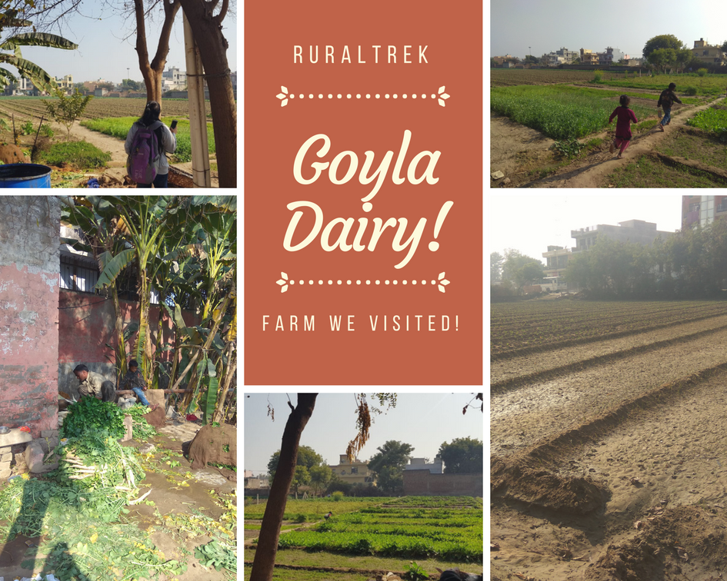As we trekked into a huge farm in Goyla Dairy, a semi-rural area in the outskirts of Dwarka, we met Gopal Singh Kushwaha, a menial hire working for Jaipal Singh, the farmer and the lord of that land. We conversed for over an hour with the two of them, our major focus being interacting with the farmer himself, Jaipal, who irrespective of being very humbly literate, had a smartphone and active internet that he knew how to use, and use well.

A vivid account has been presented hereunder. Additionally, we have recorded videos of our discussion that can be found at:

<https://www.dropbox.com/s/6zjv2918dgfhelp/Hackeam%202018.mp4?dl=0>

**Q. 1. What a kind of crops do you grow and what are your farming practices?**

A. We essentially grow vegetables – tomato, cauliflower, radish to name a few. Most of our farming makes minimal usage of chemical fertilizers and pesticides because I’ve found on internet about how harmful their overuse can prove to be. Additionally, I wish to shift to organic farming in the near future, another thing I found on the internet.

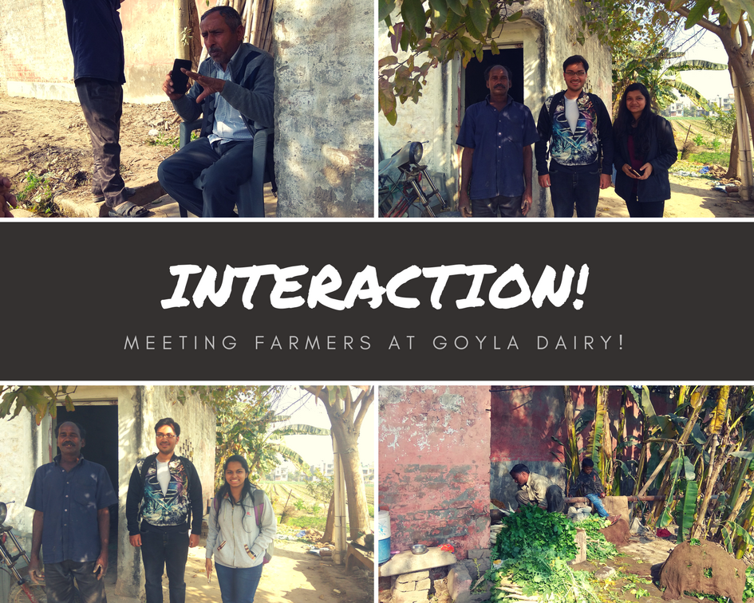**Q.2. Do all farmers have similar practices around? How aware and informed do you think they are?**

A. Though I do my part in generously sharing all the useful information I gather about farming, the extent of awareness among my fellow farmers is still pretty less despite having equal access to smartphones and internet. Primarily so because many of them are indulged in dishonest means of quick money-making. Not only do they overuse chemical fertilizers and pesticides, but also they have foul irrigation practices like using filthy sewage water for irrigation which is a malpractice particularly rampant in many areas across Delhi.

**Q.3. Will you be willing to report all these things so that something can be done?**

A. Anonymously, yes.

**Q.4. What other problems do you face in farming that you’d like to be addressed?**

A. Laborers are extremely hard to find. In fact, it is lack of availability of laborers that is, in fact, discouraging farming among people today. Our crops need timely care which requires manpower the lack of which amounts to heavy losses to the farmer, hence discouraging them to practice agriculture.

**Q.5. Where do you buy seeds, etc. from and where do you sell your product?**

A. There are various shops in and around Dwarka, Najafgarh, etc. that sell seeds, fertilizers, pesticides, machinery, etc. I’ve also purchased a heavy machine online for tilling my land. As for selling my products, Gopal and a few other men I hire take these fresh vegetables in bulk on a trolley to one of the many nearby markets.

**Q.6. Are there disparities in prices across markets (of both seeds and the crops)? Would you like something to be done about it, like if we could get your phone to know the minimum seed price and maximum ongoing rates in nearby vegetable (mandi) markets?**

A. Yes, why not! *brightens up*. It will be a great help for us!

**PROBLEMS IDENTIFIED­­­­­­­­­­­­­______________________________________________________**

1. **Irrigation from unhygienic sources:**

One of the major takeaways from our interaction with Mr. Jaipal was the popular practice of sewage water irrigation that results in quicker cop yield but gravely affects the quality of the crop produced from the land. These methods are a way to save on investment in water and earn a few extra bucks by growing quickly.

1. **Labor demand and supply:**

Problems pertaining to labor were twofold: A shortage in labor supply and a difficulty for labor to find work themselves.

1. **Seed pricing:**

Pricing of seeds is high as they are subject to rate increases from middlemen involved in the sale cycle.

1. **Fertilizer consumption:**

There is not enough awareness on the issue of excessive fertilizer consumption.

1. **Uncertainty in output of farm:**

The farmers are always uncertain about the output of their farm due to conditions like weather, farm area etc. They need some way to optimize the usage of their farm and select crops for growing based on these factors.

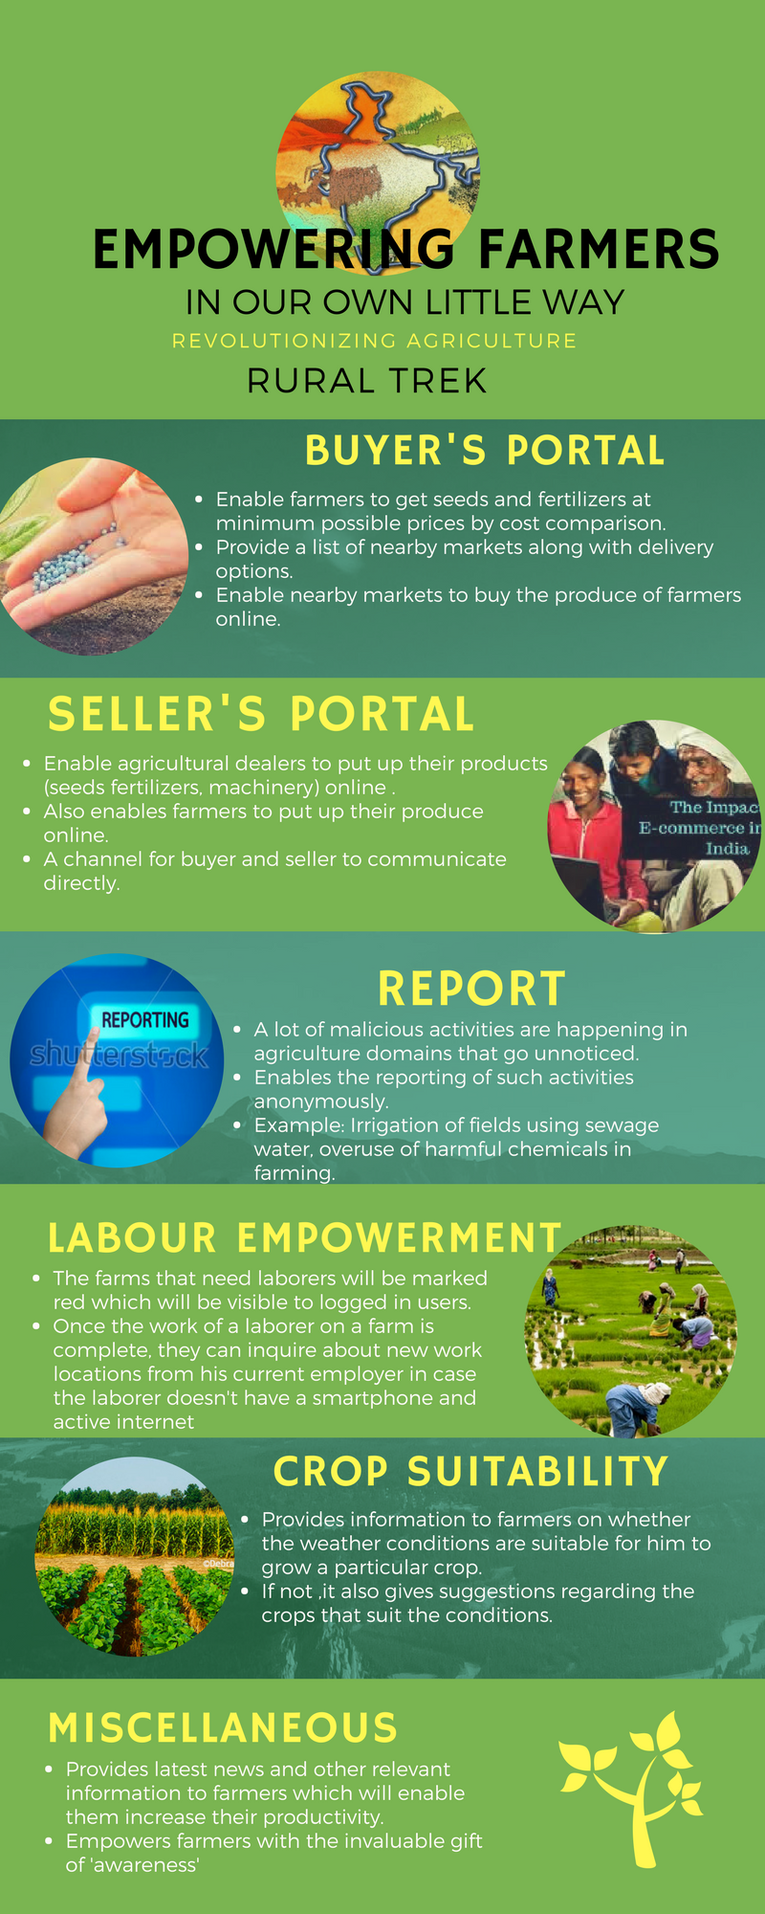**HOW WE AIM TO ADDRESS THE ISSUE? ______________________________________**

The solution we are proposing is an all-round application that can be the go-to for farmers. The farmers are confused by various sources of information and need to access them separately which can be a problem when you are new to technology.

Our application will feature a buyer and seller’s portal that can help farmers reach out and find minimum cost seeds by comparison. It will also enable them to sell their crops online thereby minimizing wastage of farm produce and finding them the most competitive selling prices.

The feature that we are most proud of is a portal for nearby people to anonymously report places that they know are indulging in malpractices. We will employ machine learning along with data cleansing using location information to ensure accuracy of resulting data. This information can be employed in markets to identify harmful yield. This will encourage farmers to adopt safer measures of irrigation as well as other common malpractices prevalent in the business.

Laborers can find work using the job portal that marks farms which require labor so that the laborers can quickly get to know about openings and don’t have to worry about finding work for their daily wages. Our application will also help farm owners decide which crops to grow based on their location, weather information and land area using linear programming and optimization.

With all the above features, we aim to help farmers find all relevant information at their fingertips in one place. Please refer to the image adjoining this text for details regarding implementation. With the adoption of this application, therefore, we are confident that farmers and laborers alike will be able to deal with daily problems much quicker and easier than before and we hope to impact the community in a positive way.

**RELEVANT FACTS AND FIGURES________________ _**

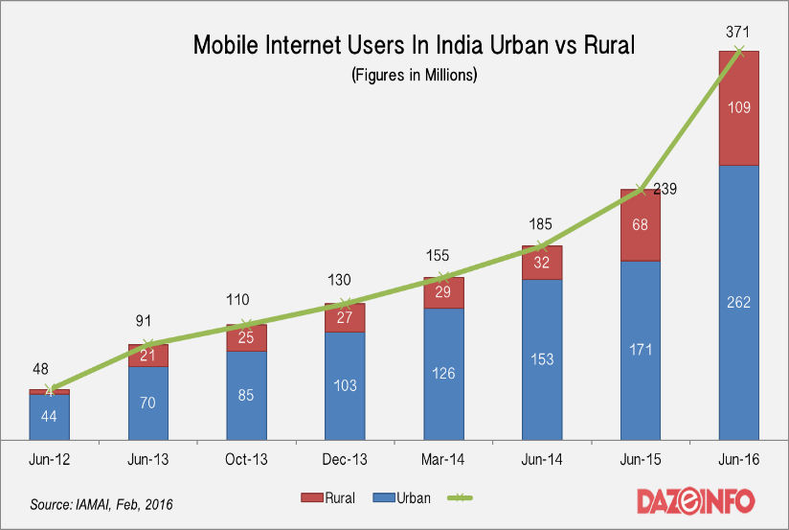

The figure clearly illustrates the ever growing number of mobile internet users in both rural and urban areas.

Contrary to popular belief rural India is not lacking behind in technology **adoption**. TRAI report states **~200 Million** [17% of 950 Million] people from rural India as opposed to ~**275 Million** [60% of 450 Million] from urban India use the Internet on their mobile devices. It’s time that we focus on Technology Solutions that can **ENHANCE** life in rural India by diffusing critical problems they face and that is what we aim to achieve.

**_____________ _**

**_____________ _**